#### JKR.PATA.F7/1

##### PELAN OPERASI DAN PENYENGGARAAN ASET (POPA)

**KERAJAAN MALAYSIA**



|  |  |  |
| --- | --- | --- |
| **TAHUN** | **:** | **_________** |

|  |  |  |
| --- | --- | --- |
| **KEMENTERIAN** | **:** | **_________________________________________________** |
| **JABATAN/ AGENSI** | **:** | **_________________________________________________** |
| **NAMA PREMIS** | **:** | **_________________________________________________** |
| **No. DPA** | **:** | |  |  |  |  |  |  |  |  |  |  |  |  |  |  |  |  |  |  |  |  |  |  |  |  | | --- | --- | --- | --- | --- | --- | --- | --- | --- | --- | --- | --- | --- | --- | --- | --- | --- | --- | --- | --- | --- | --- | --- | --- | |  |  |  |  |  |  |  |  |  |  |  |  |  |  |  |  |  |  |  |  |  |  |  |  | |

|  |  |
| --- | --- |
| **KANDUNGAN** | |
| 1.0 | Pendahuluan |
| 2.0 | Objektif |
| 3.0 | Carta Organisasi Dan Pelan Komunikasi |
| 4.0 | Skop Dan Aktiviti Perkhidmatan Pengurusan Fasiliti |
| 5.0 | Penyediaan Keperluan Sumber Aktiviti |
| 6.0 | Kawalan Rekod Operasi & Penyenggaraan Aset |
| 7.0 | Rujukan |

|  |  |  |
| --- | --- | --- |
| **1.0** | **PENDAHULUAN** | |
|  | Menjelaskan maklumat mengenai premis berkaitan. | |
| **2.0** | **OBJEKTIF** | |
|  | Menjelaskan matlamat operasi dan penyenggaraan aset peringkat agensi masing – masing. | |
| **3.0** | **CARTA ORGANISASI DAN PELAN KOMUNIKASI** | |
|  | Struktur organisasi dan pelan komunikasi perlu disediakan bagi menerangkan organisasi pelaksanaan operasi dan penyenggaraan aset sebagaimana JKR.PATA.F7/1a. | |
| **4.0** | **SKOP DAN AKTIVITI PERKHIDMATAN PENGURUSAN FASILITI** | |
|  | POF perlu menentukan/ menetapkan keperluan teknikal, proses, waktu operasi, keperluan sumber, tanggungjawab dan kuasa pegawai yang terlibat bagi aktiviti berikut seperti yang disenaraikan sebagaimana JKR.PATA.F7/1b. | |
| **5.0** | **PENYEDIAAN KEPERLUAN KOS AKTIVITI** | |
|  | POF hendaklah menyediakan analisis kos aktiviti Operasi dan Penyenggaraan Aset peringkat premis bagi tujuan permohonan peruntukan sebagaimana JKR.PATA.F7/1c. | |
| **6.0** | **KAWALAN REKOD OPERASI & PENYENGGARAAN ASET** | |
|  | Kawalan rekod operasi dan penyenggaraan aset sebagaimana JKR.PATA.F7/1d. | |
| **7.0** | **RUJUKAN** | |
|  | Sebarang dokumen yang dirujuk dalam penyediaan POPA dan Bajet Tahunan sebagaimana JKR.PATA.F7/1e. | |
|  | Disediakan Oleh: | Disahkan Oleh: |
|  | .................................. | ................................... |
|  | (cap nama & jawatan) | (POF) |
|  | Tarikh: | (cap nama & jawatan) |
|  |  | Tarikh: |

#### JKR.PATA.F7/1a

##### MODEL STRUKTUR OPERASI DAN PENYENGGARAAN ASET

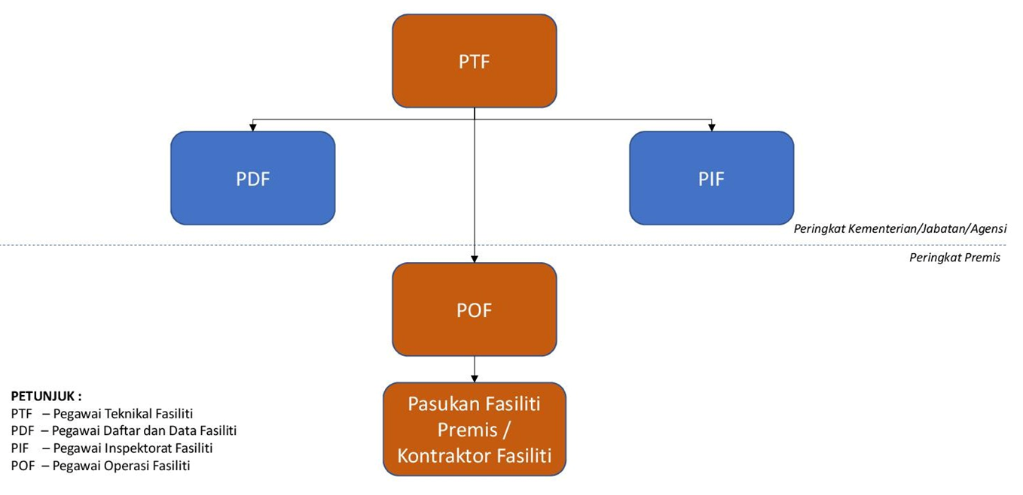

Muka Surat__dari__

**PELAN KOMUNIKASI**

|  |  |  |
| --- | --- | --- |
| **TUGAS DAN PEGAWAI ATASAN YANG ADA KAITAN** | **TANGGUNGJAWAB DAN KUASA YANG DIBERIKAN** | **TUGAS PEGAWAI-PEGAWAI LAIN YANG ADA KAITAN** |
| PTF | POF | Pasukan Fasiliti Premis /  Kontraktor Fasiliti |

Muka Surat__dari__

#### JKR.PATA.F7/1b

##### SKOP DAN AKTIVITI PERKHIDMATAN PENGURUSAN FASILITI

|  |  |  |  |  |
| --- | --- | --- | --- | --- |
| **A.** |  | **SKOP OPERASI ASET** | | |
|  |  |  | |  |
|  | **A1** |  | Pengurusan Pengemasan *(Housekeeping)* | |
|  | **A2** |  | Pengurusan Kawalan Keselamatan | |
|  | **A3** |  | Pengurusan Kawalan Makhluk Perosak | |
|  | **A4** |  | Pengurusan Landskap | |
|  | **A5** |  | Pengurusan Utiliti | |
|  | **A6** |  | Pengurusan Tenaga | |
|  | **A7** |  | Pengurusan Sisa Buangan | |
|  | **A8** |  | Pengurusan Parkir dan Trafik | |
|  | **A9** |  | Pengurusan Ruang | |
|  | **A10** |  | Lain-lain (nyatakan)…………………………… | |
|  |  | | | | |

|  |  |  |  |  |
| --- | --- | --- | --- | --- |
| **B.** |  | **SKOP PENYENGGARAAN PEMBAIKAN (PyB)** | | |
|  |  |  | |  |
|  | **B1** |  | Secara Jangkaan | |
|  | **B2** |  | Secara Luar Jangka | |
|  |  |  | |  |
|  |  |  | |  |
| **C.** |  | **SKOP PENYENGGARAAN PENCEGAHAN (PyC)** | | |
|  |  |  | |  |
|  | **C1** |  | Sivil dan Struktur | |
|  | **C2** |  | Mekanikal | |
|  | **C3** |  | Elektrikal | |
|  | **C4** |  | Infrastruktur Teknologi Maklumat (ICT) | |
|  | **C5** |  | Kemasan dan Seni Bina | |
|  | **C6** |  | Lain-lain (nyatakan)…………………………… | |
|  |  |  |  | |

|  |  |  |
| --- | --- | --- |
| Nota : Sila tandakan | Image result for tick symbol | pada bahagian yang berkenaan |

Muka Surat__dari__

|  |  |  |  |  |  |
| --- | --- | --- | --- | --- | --- |
| **Skop** | **:** | **Operasi Aset / Penyenggaraan Pembaikan (PyB) / Penyenggaraan Pencegahan (PyC)\*** |  |  |  |
| **Aktiviti** | **:** | **............................................................................................................** | **Tahun** | **:** | **....................................** |

|  |  |  |  |  |  |  |  |  |  |  |  |  |  |  |  |
| --- | --- | --- | --- | --- | --- | --- | --- | --- | --- | --- | --- | --- | --- | --- | --- |
| **BUTIRAN**  **AKTIVITI** | **PIHAK BERKAITAN** | **TANGGUNGJAWAB** | **TEMPOH PELAKSANAAN (BULAN / MINGGU)** | | | | | | | | | | | | **CATATAN** |
| **1** | **2** | **3** | **4** | **5** | **6** | **7** | **8** | **9** | **10** | **11** | **12** |  |
|  |  |  |  |  |  |  |  |  |  |  |  |  |  |  |  |
|  |  |  |  |  |  |  |  |  |  |  |  |  |  |  |  |
|  |  |  |  |  |  |  |  |  |  |  |  |  |  |  |  |
|  |  |  |  |  |  |  |  |  |  |  |  |  |  |  |  |
|  |  |  |  |  |  |  |  |  |  |  |  |  |  |  |  |
|  |  |  |  |  |  |  |  |  |  |  |  |  |  |  |  |
|  |  |  |  |  |  |  |  |  |  |  |  |  |  |  |  |
|  |  |  |  |  |  |  |  |  |  |  |  |  |  |  |  |
|  |  |  |  |  |  |  |  |  |  |  |  |  |  |  |  |
|  |  |  |  |  |  |  |  |  |  |  |  |  |  |  |  |
|  |  |  |  |  |  |  |  |  |  |  |  |  |  |  |  |
|  |  |  |  |  |  |  |  |  |  |  |  |  |  |  |  |
|  |  |  |  |  |  |  |  |  |  |  |  |  |  |  |  |
|  |  |  |  |  |  |  |  |  |  |  |  |  |  |  |  |
|  |  |  |  |  |  |  |  |  |  |  |  |  |  |  |  |

*Nota :*

1. *\*Potong mana yang tidak berkenaan*
2. *Maklumat tempoh pelaksanaan dibawa ke Borang JKR.PATA-2C*

Muka Surat__dari__

#### JKR.PATA.F7/1c

##### ANALISIS KOS AKTIVITI OPERASI DAN PENYENGGARAAN ASET

|  |  |  |
| --- | --- | --- |
| **TAHUN** | **:** | **__________________________** |
| (Peringkat Premis) | | |

|  |  |  |  |  |  |  |  |  |  |  |  |  |  |  |  |  |  |  |  |  |  |  |  |  |  |  |  |
| --- | --- | --- | --- | --- | --- | --- | --- | --- | --- | --- | --- | --- | --- | --- | --- | --- | --- | --- | --- | --- | --- | --- | --- | --- | --- | --- | --- |
| Kementerian | : | .................................................................................................... | | | | | | | | | | | | | | | | | | | | Jabatan/ Agensi | | | | : | ....................................... |
| Negeri/ Wilayah | : | .................................................................................................... | | | | | | | | | | | | | | | | | | | | Daerah | | | | : | ....................................... |
| Nama Premis | : | .................................................................................................... | | | | | | | | | | | | | | | | | | | |  | | | |  |  |
| No. DPA | : |  |  |  |  |  |  |  |  |  |  |  |  |  |  |  |  |  |  |  |  |  |  |  |  |  |  |

|  |  |  |  |  |  |  |  |  |  |  |  |  |  |  |  |
| --- | --- | --- | --- | --- | --- | --- | --- | --- | --- | --- | --- | --- | --- | --- | --- |
| **SKOP** | **AKTIVITI** | **BUTIRAN AKTIVITI** | **KOS (RM)** | | | | | | | | | | | **JUMLAH KOS**  **(RM)** | **PENGURUSAN (Dalaman/ Luaran)** |
| **OBJEK SEBAGAI (OS) / KEPALA PERUNTUKAN** | | | | | | | | | | |
| **22000** | **23000** | **24000** | **26000** | **27000** | **28000** | **29000** | **32000** | **33000** | **51000** | **Lain-lain** |
|  |  |  |  |  |  |  |  |  |  |  |  |  |  |  |  |
|  |  |  |  |  |  |  |  |  |  |  |  |  |  |  |  |
|  |  |  |  |  |  |  |  |  |  |  |  |  |  |  |  |
| **JUMLAH** | | |  |  |  |  |  |  |  |  |  |  |  |  |  |

Catatan: ...........................................................................................................................................................................................................................................

..........................................................................................................................................................................................................................................................

*Nota : Maklumat jumlah kos keseluruhan dibawa ke borang JKR.PATA.F7/2 dan JKR.PATA.F7/3*

#### JKR.PATA.F7/1d

##### KAWALAN REKOD OPERASI & PENYENGGARAAN ASET

|  |  |  |  |
| --- | --- | --- | --- |
| **BIL** | **JENIS REKOD** | **LOKASI** | **TEMPOH PENYIMPANAN** |
|  |  |  |  |
|  |  |  |  |
|  |  |  |  |
|  |  |  |  |
|  |  |  |  |
|  |  |  |  |
|  |  |  |  |
|  |  |  |  |
|  |  |  |  |
|  |  |  |  |
|  |  |  |  |
|  |  |  |  |
|  |  |  |  |
|  |  |  |  |
|  |  |  |  |
|  |  |  |  |
|  |  |  |  |
|  |  |  |  |

#### JKR.PATA.F7/1e

##### RUJUKAN

|  |  |
| --- | --- |
| **BIL** | **DOKUMEN RUJUKAN** |
|  |  |
|  |  |
|  |  |
|  |  |
|  |  |
|  |  |
|  |  |
|  |  |
|  |  |
|  |  |
|  |  |
|  |  |
|  |  |
|  |  |
|  |  |
|  |  |
|  |  |